Welcome Newsletter
THIS MONTH AT A GLANCE
Welcome to Utah Ballet Academy! We hope you’re all having a wonderful summer and have made some great memories. We’re excited to get back into the studio to see all our returning students and meet our new friends. Classes start August 25th.

Important Dates
August 25th – First day of classes!
September 2nd – Labor day. No classes
October 17th-21st - Fall Break. No classes
November 27th - 29th - Thanksgiving break (no classes)
December 23rd – Jan 3rd – Christmas Break (No classes)
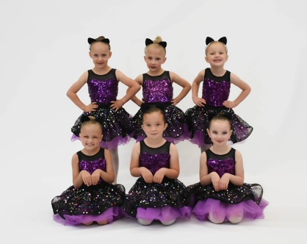

Fees
Fees are calculated on a monthly basis with statements being emailed at the end of each month. Payments are due at the beginning of each month on the 1^{st.} This year a $5 late fee will be charged on the 10th for any unpaid tuition.
The first payment is due September 1st. This allows for a full month of tuition in December. Payment can be made via cash, check or Venmo. @Carrie-Wright.24. I am currently working on a direct deposit option.
Uniform
All grades preprimary and up have a uniform that should be worn to class. However, some of the items are backordered, so If your child doesn’t have the uniform yet then an alternative leotard can be worn, or a t-shirt and leggings. Girls hair should be tied back off the face and neck, preferably in a bun. No jewelry except stud earrings should be worn to class. Preschool class students can wear any leotard, tights and ballet shoes they choose. Although if leotard and tights are tricky to handle independently in the bathroom then appropriate, comfortable clothing may be worn.

